

Static Web Page Design

LAB MANUAL

Department

Of

Computer Engineering

# Neotech Faculty of Diploma Engineering

**Name: - ________________________________________________________________________________________**

**Branch: - _________________________________ Division: - _________________________________________**

**Roll No: - ___________________________________ Year: - ___________________________________________**

**NEOTECH FACULTY OF DIPLOMA ENGINEERING**

**Static Web Page Design(4311603)**



Neotech Faculty Of

Diploma Engineering

Virod, Vadodara.

CERTIFICATE

This is to certify that

Mr./Ms. Enrollment No._____________________ of 2nd Semester Diploma course

In has satisfactorily completed his/her termwork

In with in four walls of institute during the year 2022.

Place:

Date:

Subject Teacher Head of Department

**Subject: Static Web Page Design**

## Subject Code : 4311603

**LIST OF EXPERIMENTS**

|  |  |  |  |  |
| --- | --- | --- | --- | --- |
| **Sr.**  **NO.** | **TITLE OF EXPERIMENT** |  | **Date** | **Sign** |
| 1. | Use HTML text formatting tags to create web page as per given sample. |  |  |  |
| 2. | Use hyper link tag to navigate through different web pages as per given sample. |  |  |  |
| 3. | Use image tags to create web page as per given sample. |  |  |  |
| 4. | Use HTML table tags to create web page as per given sample. |  |  |  |
| 5. | Use sorted list to create web page as per given sample page |  |  |  |
| 6. | Use unsorted list to create web page as per given sample page. |  |  |  |
| 7. | Use definition list to create web page as per given sample page. |  |  |  |
| 8. | Use semantic tags to organize web page contents as per given sample. |  |  |  |
| 9. | a. Create a student registration webpage using different HTML form elements.  b. Create student feedback form using different HTML form elements. |  |  |  |
| 10. | Create a bank account opening form using different HTML form elements in Kompozer |  |  |  |
| 11. | Use inline, internal and external style sheets for the student registration form and bank account form created in previous practical. |  |  |  |
| 12. | a. Use different CSS elements to create and format your Profile Page (Note: use CSS Background, Text, Font, Tables, Links, Images, Margin etc)  b. Create and format your class time table Page Using Different CSS Elements (Note: use CSS Background, Text, Font, Tables, Links, Images, Margin etc) |  |  |  |
| 13. | Use JavaScript to perform the following operations: a. find roots of quadratic equation b. find the highest from given three values |  |  |  |
| 14. | Use JavaScript to check whether given character is vowel or consonant using if else ladder. |  |  |  |
| 15. | Use JavaScript to check whether given character is vowel or consonant using switch case. |  |  |  |
| 16. | Use JavaScript to print first 10 even numbers. |  |  |  |
| 17. | Use JavaScript to calculate power of given number. |  |  |  |
| 18. | Use JavaScript to print multiplication table of given number. |  |  |  |
| 19. | Use JavaScript user defined functions to perform the following operations:  a. to calculate sum of 1 to n  b. to check whether given number is prime or not |  |  |  |
| 20. | Use JavaScript to perform the following operations:  a. take input of student name and address and display in a dialog box.  b. change background color of webpage as selected by user from a list of colors given in combo box. |  |  |  |
| 21. | Use JavaScript to perform the following operations:  a. calculate the factorial of a given number entered into a textbox. Display the result in another textbox.  b. perform arithmetic operations on two numbers entered into textboxes. Use Radio buttons to select arithmetic operations (Addition, Subtraction, Multiplication and Division). Display the result in another textbox. |  |  |  |

### Experiment No:- 1 Date: / /

**Aim :** **Use HTML text formatting tags to create web page as per given sample.**

**1.Paragraph in HTML page:**

**<HTML>**

**<HEAD>**

**<TITLE>Title of this page</TITLE>**

**</HEAD>**

**<BODY>**

**Another line behind this statement.**

**Paragraph is over here.**

**Here is new line.**

**<NOBR>**

**This line don’t write on another line.**

**This line don’t write on another line.**

**This line don’t write on another line.**

**</NOBR>**

**<P>**

**End line.**

**<HR>**

**</BODY>**

**</HTML>**

**Output:**

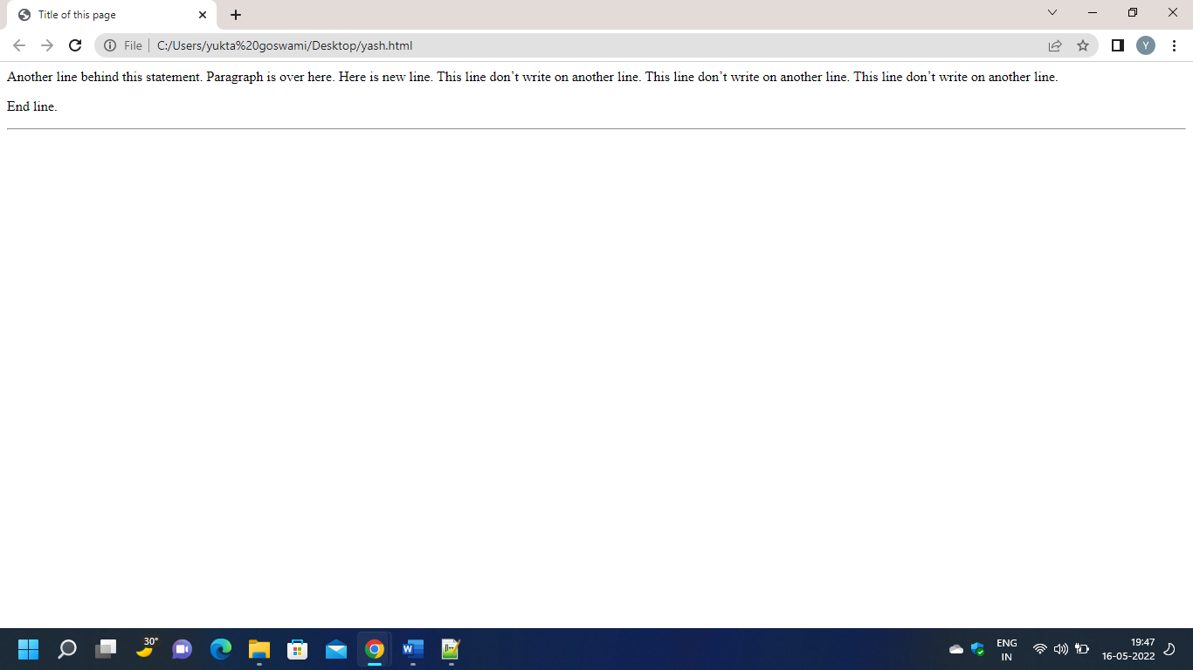

**2.Colors in HTML page:**

**<HTML>**

**<HEAD>**

**<TITLE>Title of this page</TITLE>**

**</HEAD>**

**<BODY BGCOLOR=”Aqua”>**

**<H1><FONT COLOR=”#FF00FF”>Welcome</FONT></H1>**

**</BODY>**

**</HTML>**

**Output:**

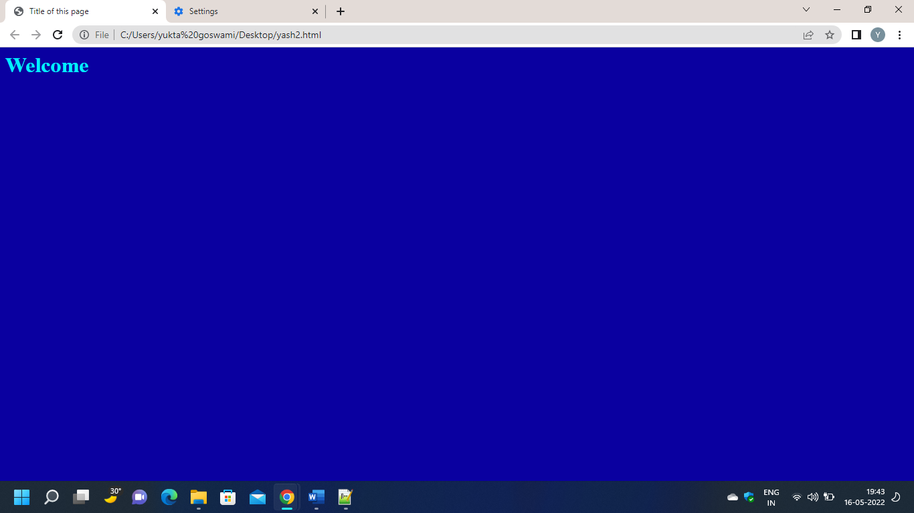

**Experiment:-2**

**3.Hyperlink to HTML**

**<html>**

**<head></head>**

**<BODY>**

**<A href="new.html">click the link</A>**

**</BODY>**

**</html>**

* **second HTML File**

**<html>**

**<head></head>**

**<title>Programing</title>**

**<BODY>**

**<h1>C++ theory</h1>**

**<h3>1) Object. This is the basic unit of object oriented prgraming..</h3>**

**<h3>2) class When you define a class you define a blueprint for an object..</h3>**

**<h3>3) Abstraction..</h3>**

**<h3>4) Encapsulation..</h3>**

**<h3>5) Inheritance..</h3>**

**<h3>6) polymorphism..</h3>**

**</BODY>**

**</html>**

* **Output**

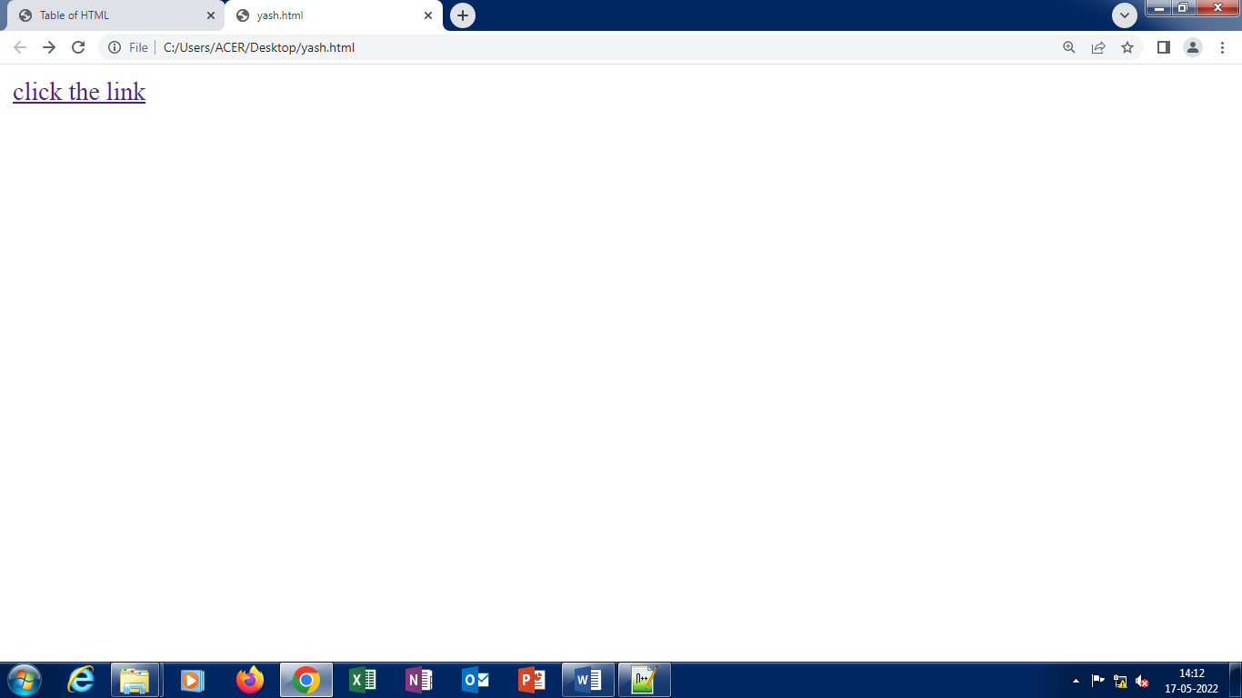

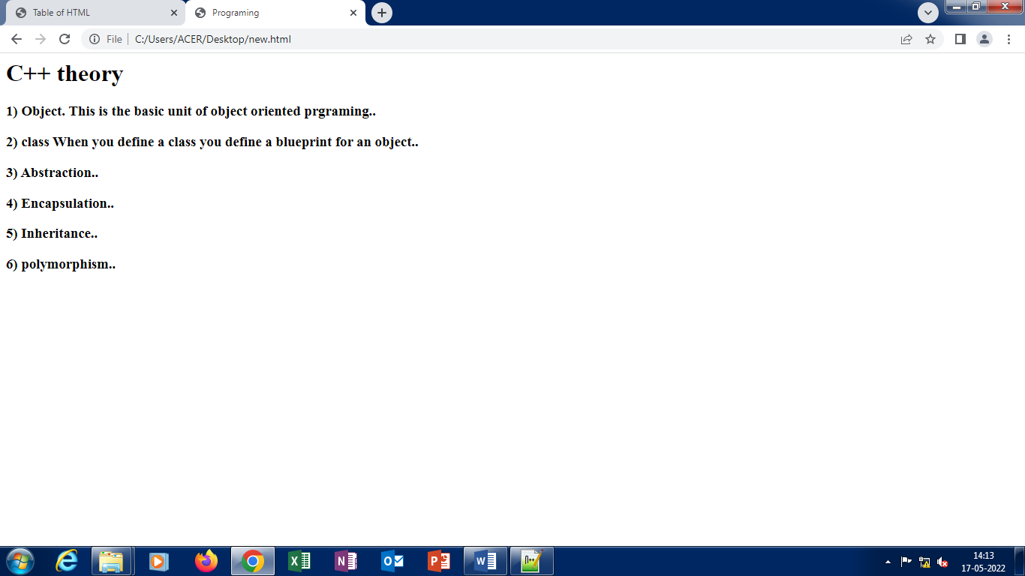

**EXPERIMENT:-3**

* **Use of images in HTML**

**<html>**

**<head></head>**

**<body>**

**<h1>Use of Images in HTML</h1>**

**<img src="rose.jpg" width=50%>**

**</body>**

**</html>**

**OUTPUT:-**

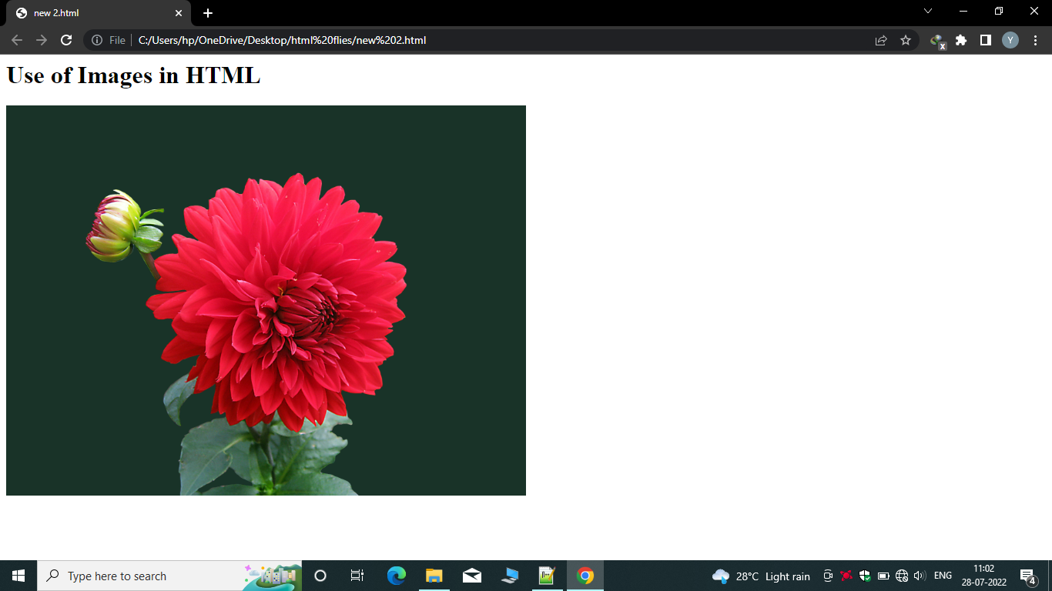

**EXPERIMENT:-4**

* Use HTML table tags

**<html>**

**<body>**

**<table border="1">**

**<caption align="bottom">Caption for the Table</caption>**

**<tr>**

**<th>column 1</th>**

**<th>comlum 2</th>**

**</tr>**

**<tr>**

**<td>row 1, column 1</td>**

**<td>row 1, column 2</td>**

**</tr>**

**<tr>**

**<td>row 2, column 1</td>**

**<td>row 2, column 2</td>**

**</tr>**

**</table>**

**</body>**

**</html>**

**OUTPUT:-**

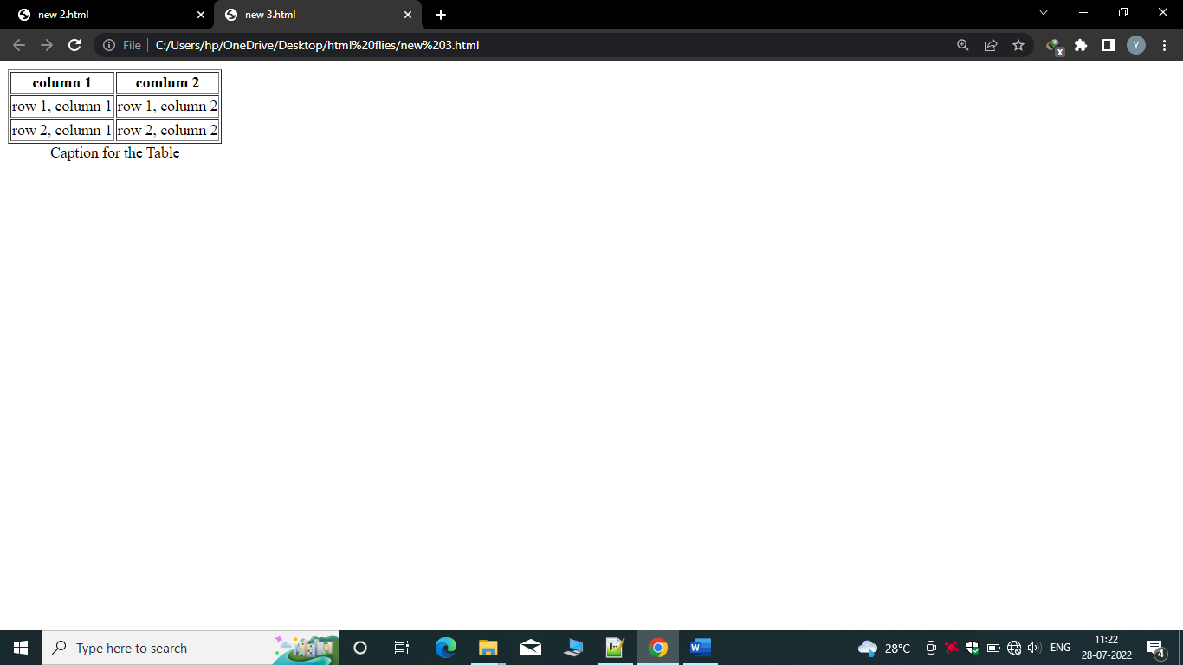

**Experiment 5:-**

**<html>**

**<body>**

**<h4>Disc Bulltets list</h4>**

**<ul types="Disc">**

**<li>Milk</li>**

**<li>Tea</li>**

**<li>Bread</li>**

**</ul>**

**</body>**

**</html>**

**Output:-**

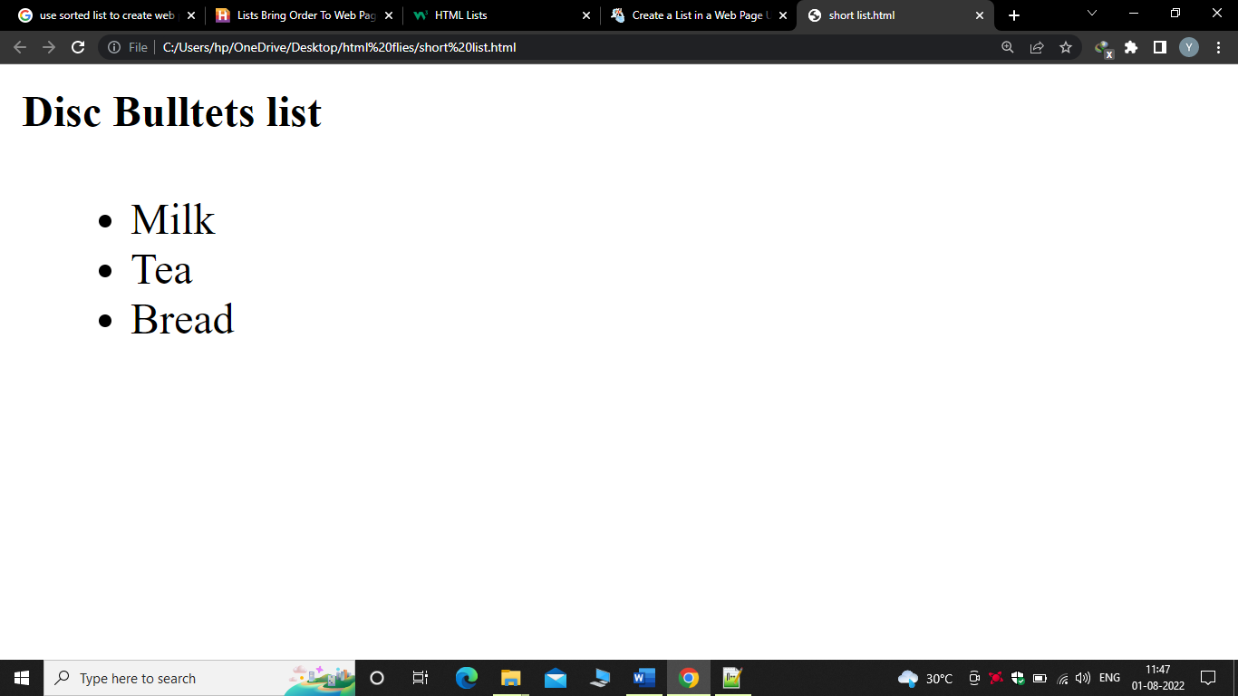

**Experiment:-6**

**<html>**

**<body>**

**<h2>An unsorted HTML list</h2>**

**<ul>**

**<li>Coffee</li>**

**<li>Tea</li>**

**<li>Milk</li>**

**</ul>**

**</body>**

**</html>**

**Output:-**

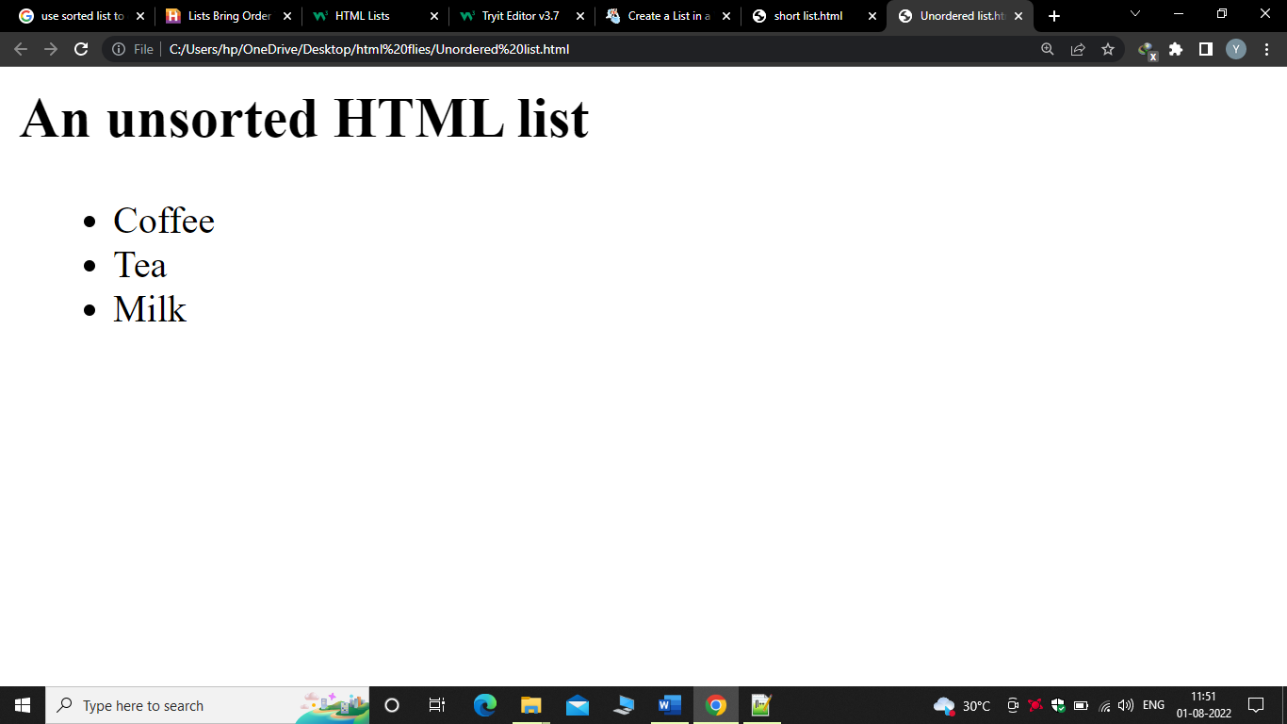

**Experiment:-7**

**<html>**

**<body>**

**<h1> Definition List</h1>**

**<dl>**

**<dt>HTML</dt>**

**<dd>Hyper Text Markup Language</dd>**

**<dt> Dog</dt>**

**<dd>A Human's best friend!</dd>**

**</dl>**

**</body>**

**</html>**

**Output:-**

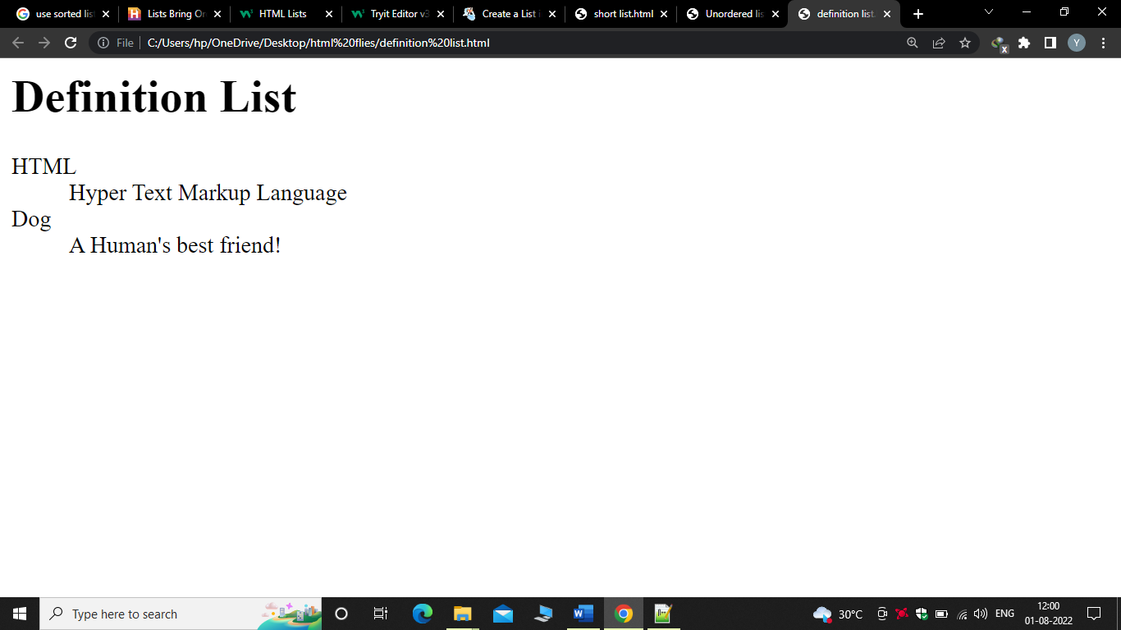

**Experiment 8 :**

**Aim: use semantic tags to organize webpage contents**

**Program:**

**<html>**

**<head>**

**<title> Neotech campus </title>**

**</head>**

**<body bgcolor="yellow">**

**<h1>**

**<center>**

**<header> Neotech campus </header>**

**</center>**

**</h1>**

**<p>**

**<nav>**

**<h2>**

**<a href="#">Home</a>**

**<a href="#">Activity</a>**

**<a href="#">photo gallery</a>**

**<a href="#">contactus</a>**

**<a href="#">google</a>**

**</h2>**

**</nav>**

**</p>**

**<main>**

**<h3>about campus</h3>**

**<p> My Campus is one of the best and most reputed school of this city. My college offers education right from**

**My college is equipped by with all sorts of modern day facility to enhance education.**

**My college has a play ground , an assembly hall ,library,and activity lab**

**</p>**

**</main>**

**<hr size="3" color="red">**

**<article>**

**<p> My school offers teaching in english and it is affiliated to GTU.The teachers in my school make learing easy**

**and**

**intersting by providing presentation and demonstrations.**

**</p>**

**</article>**

**<footer>visit our campus</footer>**

**</body>**

**</html>**

**Output:**

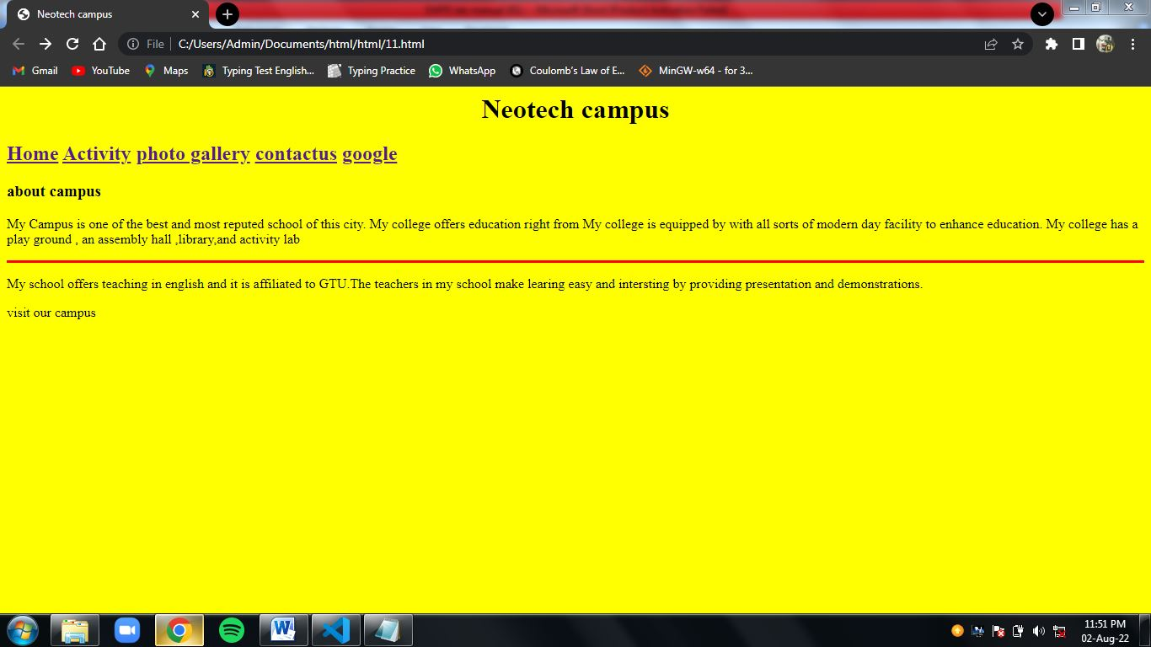

**Experiment 9.a :**

**Aim:** a. Create a student registration webpage using different HTML form elements.

**Program**

**<!DOCTYPE html>**

**<html lang="en">**

**<head>**

**<title>Form</title>**

**</head>**

**<body bgcolor="lightblue">**

**<center><img src="C:\Users\Admin\Documents\html\html\newwebpage\download.png"></center>**

**<h1>**

**Enter the information of the student**

**</h1>**

**<br>**

**<form>**

**Name : <input placeholder=" full Name" title="full name" type="text">**

**<br>**

**<br>**

**last name : <input placeholder="last Name" type="text">**

**<br>**

**<br>**

**Mobile Number : <input placeholder="Mobile Number" type="number">**

**<br>**

**<br>**

**Male/female : <input id="check" placeholder="male/female" type="radio">**

**<label for="check">male</label>**

**<input id="check" placeholder="male/female" type="radio">**

**<label for="check">female</label>**

**<br>**

**<br>**

**Email : <input placeholder="Email" type="email">**

**<br>**

**<br>**

**<input type="submit">**

**</form>**

**</body>**

**</html>**

**Output:**

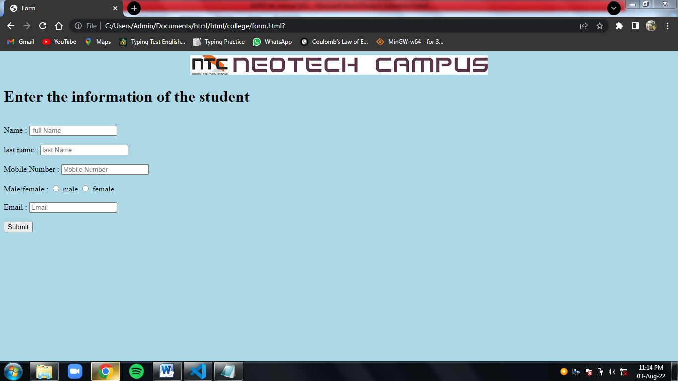

**Program b**

**<!DOCTYPE html>**

**<html lang="en">**

**<head>**

**<title>product detalis</title>**

**</head>**

**<body bgcolor="lightblue">**

**<br>**

**<h2>Adder product details</h2>**

**<hr>**

**<br>**

**<form>**

**product name <input type="text" placeholder="product name" required>**

**<br>**

**<br>**

**product type <input type="text" placeholder="product type" required>**

**<br>**

**<br>**

**product price <input type="number" placeholder="product price" required>**

**<br>**

**<br>**

**product image <input type="url"placeholder="Enter url">**

**<br>**

**<br>**

**rate our product <input type="range">**

**<br>**

**<div style="padding-left: 112px;flex: 1px;">**

**1 &nbsp;&nbsp;&nbsp;&nbsp;2 &nbsp;&nbsp;&nbsp;&nbsp;3 &nbsp;&nbsp;&nbsp;&nbsp;4 &nbsp;&nbsp;&nbsp;&nbsp;5**

**</div>**

**<br>**

**<br>**

**<button>submit</button>**

**</form>**

**</body>**

**</html>**

**Output:**

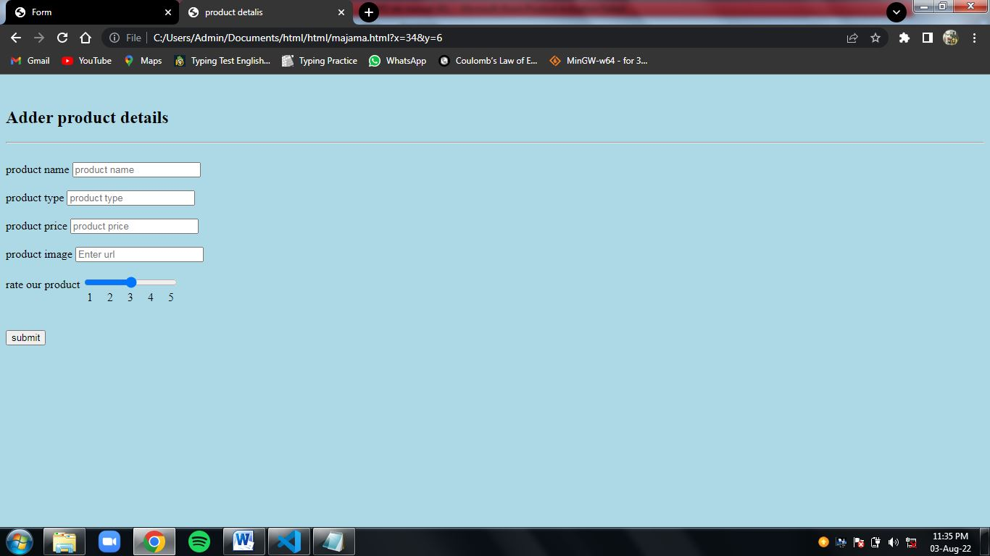

**Experiment 10 :**

**Aim:** Create a bank account opening form using different HTML form elements in Kompozer

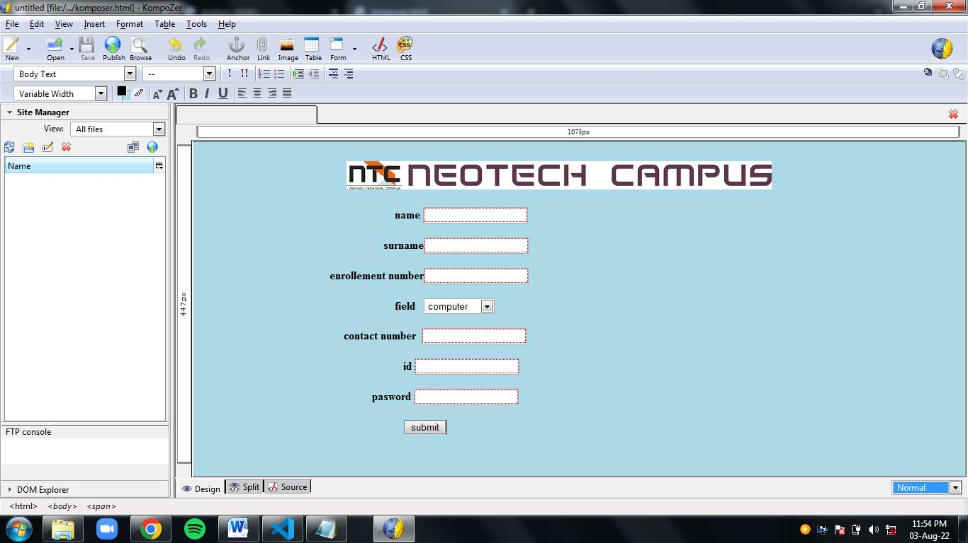

**Output:**

